ChatGPT: A game-changer in the field of education

1. Introduction

Artificial intelligence (AI) chatbots are a famous innovation that has attracted a lot of interest for their possible use cases beyond a wide range of sectors. Chatbot named ChatGPT was created by OpenAI and made available in November 2022. It was developed on top of the OpenAI large language models (LLMs) from the GPT-3.5 and GPT-4 domains, and it was then quite well (a method of action recognition) with using controlled and reinforced academic skills.

* 1. Chatbots and its past

A chatbot is an artificially intellectual system that includes emotional discussions with humans using an interactive platform, generally via either speech or text, using machine learning, natural language processing (NLP) and AI technology. Chatbots can be programmed to give knowledge, join discussions, respond to queries, and carry out tasks.

Initial chat systems were created in the 1960s, which is when chatbots first appeared. Their origins can be dated to the middle of the twentieth century. Historically, one of the first chatbot systems that imitated discussions with a psychiatrist by employing basic pattern recognition methods was Joseph Weizenbaum's ELIZA, developed in 1964. Since AI and NLP technology have advanced since then, chatbots have undergone a considerable evolution.

It attracted popularity because of its thorough comments and well-spoken explanations in a variety of subject areas. Yet, a key flaw in it has been recognized as its inconsistent truthiness. With the introduction of ChatGPT, OpenAI was valued at $29 billion in 2023, according to estimates.

* 1. Fundamentals of chatbot

Due to its capacity for engaging with consumers, entertainment, problem-solving, trendiness, and personalization choices, chatbots have grown in importance in customer service. According to a study report, chatbots that have excellent system quality, information quality, and service quality have a beneficial effect on service quality. Moreover, as chatbots alter the nature of customer support, experiences, and relationship management, they can improve the customer experience. According to the same article, chatbots might result in creative approaches to consumer self-service and a decrease in service costs, but businesses must get more knowledge about how service usage affects KPIs like customer happiness, loyalty, and the desire to reuse service applications. Another research demonstrates the importance of chatbots in gauging consumer happiness and fostering brand partnerships.

* 1. Different classifications of chatbot

Chatbots can be classified based on various parameters. One of them is the knowledge domain, which distinguishes between open and closed domain chatbots. Open domain chatbots can talk about general topics, while closed domain chatbots are focused on a specific domain. Another parameter is the service provided, which classifies chatbots as interpersonal, intrapersonal, or inter-agent. Interpersonal chatbots provide services such as restaurant or flight booking, while intrapersonal chatbots exist within the personal domain of the user. Classification based on goals considers the primary goal chatbots aim to achieve, such as informative, chat-based/conversational, or task-based chatbots. The input processing and response generation method is another parameter that considers the method of processing inputs and generating responses. Three models used to produce appropriate responses are the rule-based model, retrieval-based model, and generative model. Rule-based model chatbots select the system response based on a fixed predefined set of rules, while retrieval-based chatbots retrieve some response candidates from an index before applying the matching approach to the response selection. Generative model chatbots use machine learning algorithms and deep learning techniques to generate answers in a better way. However, they are difficult to build and train.

Figure 1 Classification of chatbot taken from the

* 1. Background of chatGPT and exactly how it is varied from usual chatbots.

ChatGPT is an AI chatbot developed by OpenAI that is trained using deep learning algorithms to generate human-like responses to text prompts. It is a sibling model to InstructGPT, which is trained to provide detailed responses based on instructions given in prompts. ChatGPT has gained significant attention due to its ability to generate coherent and contextually relevant responses. Microsoft has invested billions in ChatGPT, stating that it is as important as the invention of the PC.

ChatGPT differs from normal chatbots in that it is trained using a large dataset of human conversations, allowing it to generate more natural and contextually relevant responses compared to rule-based chatbots. Chatbots follow pre-programmed rules to respond to user inputs, whereas ChatGPT generates its responses based on patterns learned from a large set of human conversations. ChatGPT can also generate more creative and open-ended responses compared to rule-based chatbots. However, ChatGPT may not always provide accurate or appropriate responses due to its training on human conversation data, which may contain biases and stereotypes.

* 1. Working mechanism of ChatGPT

ChatGPT is a conversational AI model that utilizes the Generative Pre-trained Transformer 3 (GPT-3) architecture to generate human-like responses to user inputs. The GPT-3 architecture is a transformer model that uses self-attention mechanisms to process input sequences. The model is pre-trained on a large corpus of text data and can be fine-tuned to specific domains to improve its performance on a particular task.

To use ChatGPT, a user inputs a text message, which is then processed by the model. The model generates a response based on the input message and its context. The generated response is then returned to the user. The process is repeated for each subsequent message in the conversation.

Several research papers have explored the capabilities of ChatGPT and its underlying architecture. In a study, researchers used ChatGPT to generate responses to medical-related queries, suggesting that it could be used as a tool to assist healthcare professionals in diagnosing and treating patients (Rajkomar et al., 2021). Another study explored the use of ChatGPT in generating code snippets in response to natural language queries (Qin et al., 2021).

In conclusion, ChatGPT is an advanced conversational AI model that utilizes the GPT-3 architecture to generate human-like responses to user inputs. The model is pre-trained on a large corpus of text data and can be fine-tuned to specific domains to improve its performance on a particular task. Several research papers have explored the capabilities of ChatGPT, and the results suggest that it has the potential to revolutionize several industries, including healthcare and software development.

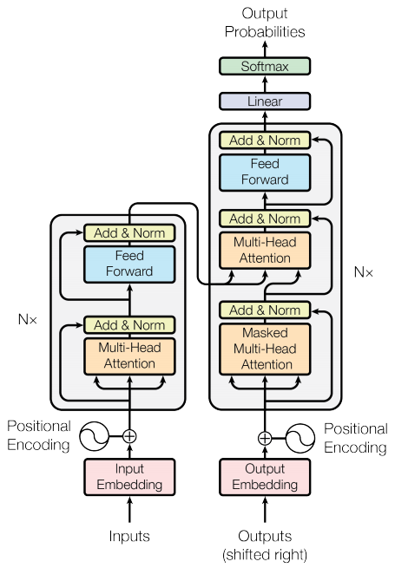

Figure 2 The Transformer - model architecture screenshot taken from the 31st Conference on Neural Information Processing Systems (NIPS 2017), Long Beach, CA, USA

1. Literature review

ChatGPT, an advanced conversational AI model utilizing the Generative Pre-trained Transformer 3 (GPT-3) architecture, is becoming a game-changer in the field of education. This technology has the potential to revolutionize the way students learn, interact with teachers, and access educational resources. In this literature review, we will discuss how ChatGPT is being used in the field of education, its NLP applications, the potential advantages and disadvantages of its use, the technical implementation, and the performance issues related to ChatGPT.One of the most significant NLP applications of ChatGPT in education is personalized feedback. In a study conducted by Wang et al. (2021), the researchers trained the model on a large corpus of student essays and used it to provide feedback that was relevant and helpful to the students. Another study by Liu et al. (2020) used the same model to generate explanations for mathematical concepts, which helped students better understand difficult topics. ChatGPT can also be used to create chatbots that offer a more interactive and engaging learning experience for students (Liu et al., 2021). Additionally, ChatGPT can generate sign language animations in response to natural language queries, providing a new way for deaf and hard-of-hearing individuals to access educational content (Li et al., 2021). One of the major advantages of using ChatGPT in education is its ability to provide personalized feedback to students. This can help students improve their understanding of a subject and their overall learning outcome. ChatGPT can also be used to create chatbots that offer a more interactive and engaging learning experience for students. Additionally, ChatGPT can help improve accessibility to education for students who may have difficulty accessing educational content due to disabilities or language barriers.One of the major concerns about using ChatGPT in education is the potential for bias in AI-generated content, particularly in terms of gender and race (Bolukbasi et al., 2016). Additionally, there are concerns about the quality of the feedback provided by ChatGPT and the potential for students to rely too heavily on AI-generated content rather than interacting with human teachers. Another concern is the potential for technical issues and errors that can occur while using ChatGPT.To use ChatGPT in education, the model must be trained on a large corpus of relevant text data. The model can then be fine-tuned to specific domains to improve its performance on a particular task. The model can be integrated into existing educational platforms or used to create new educational tools.One of the major performance issues with ChatGPT is the potential for technical errors and inaccuracies. The model may generate responses that are irrelevant or incorrect, which can lead to confusion and frustration for students. Additionally, the model may not perform well on tasks that it has not been specifically trained for. ChatGPT is becoming a game-changer in the field of education, offering personalized feedback, improved accessibility, and interactive learning experiences. However, there are also concerns about the potential for bias and the need for further research to fully realize the potential benefits of this technology. Technical implementation and performance issues must also be addressed to ensure that ChatGPT is a reliable and effective tool for education.